ECE 560 B6 Lab 4 Report

Silicon Photonics Systems

Sumant Sakhalkar

CSU ID: 831685037

**Objective:**

To simulate MRRs in MODE (low accuracy) and FDTD (high accuracy) using the Lumerical Knowledge Base and compare it’s plots with the existing plots for MATLAB code for MRR

**Summary of Approach:**

The links provided by Professor Mahdi explained the step by step design synthesis for ring resonator in MODE and FDTD.

**MRR Design in MODE**

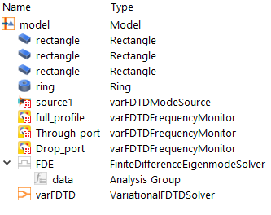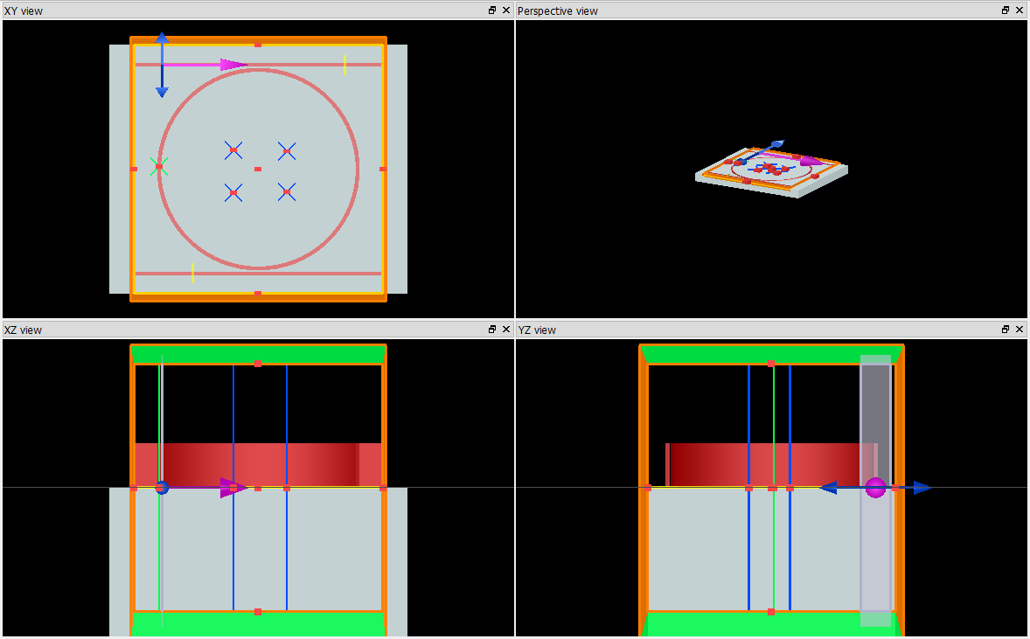

**OBJECT TREE**

**MRR Design in FDTD**

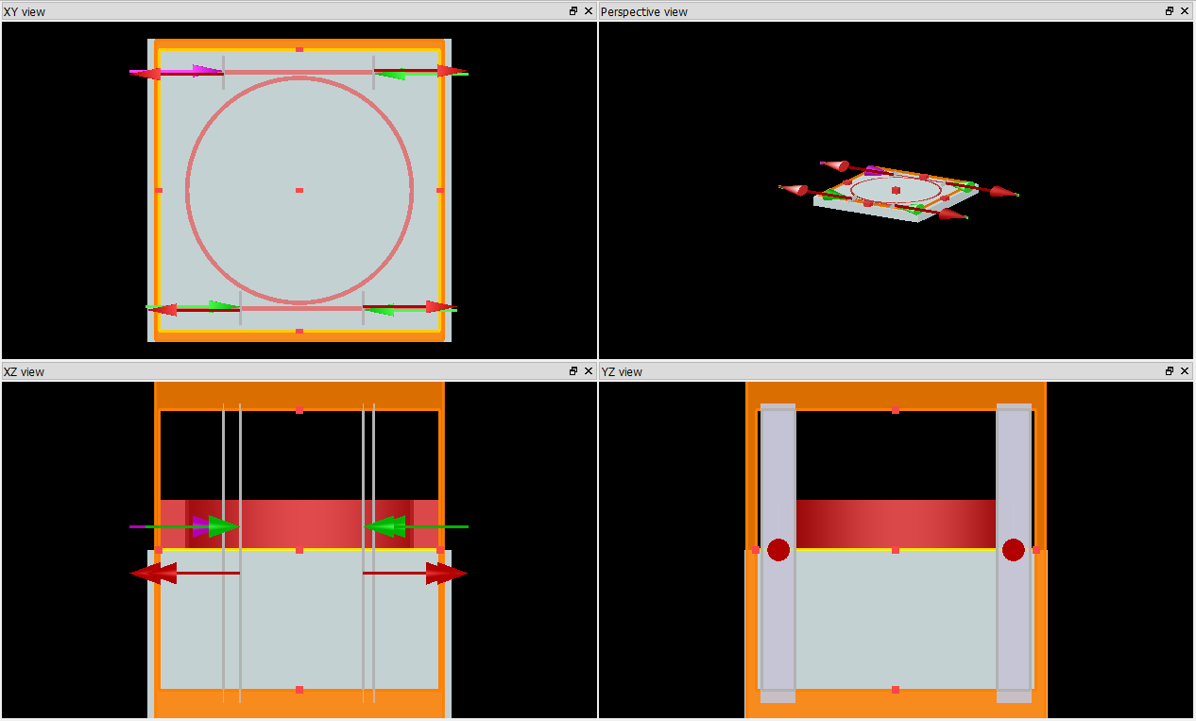

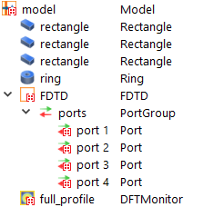

**OBJECT TREE**

NOTE: I have used just one entire ring of radius specifically for this lab as we are not using a coupler. I am not going to use this for any other lab.

The design and implementation of this was easy, the challenge was to combine these plots together. Hence, using Lumerical scripting I designed two scripts one for MODE and one for FDTD simulations. The purpose of writing this script was to export the MODE and FDTD data on to a .mat file which was then imported into the TMM_ring.m MATLAB code (modified specifically for my LAB) and the results were plotted to compare the results from MODE, FDTD and the MATLAB code.

**Script for MODE**

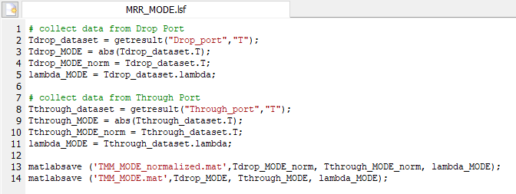

**Script for FDTD**

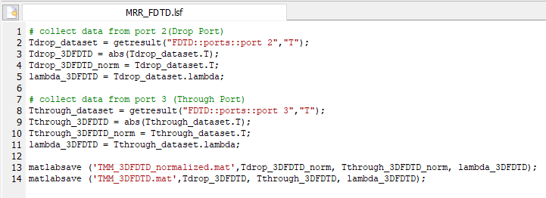

**Challenges faced:**

Since, the MATLAB code was based on mathematical equations, the plots are mathematical rather than simulation based. Hence, the plot from MATLAB code was symmetrical. Also the plots of the original MATLAB code were not normalized because of which the values in its plot were almost 12 dB and 35 dB below respectively for drop port and through port as compared to the plots obtained from MODE and FDTD as shown below. Another challenge was to combine these plots together. As mentioned before, I designed two scripts to export the MODE and FDTD data on to a .mat file which was then imported into the MATLAB code.

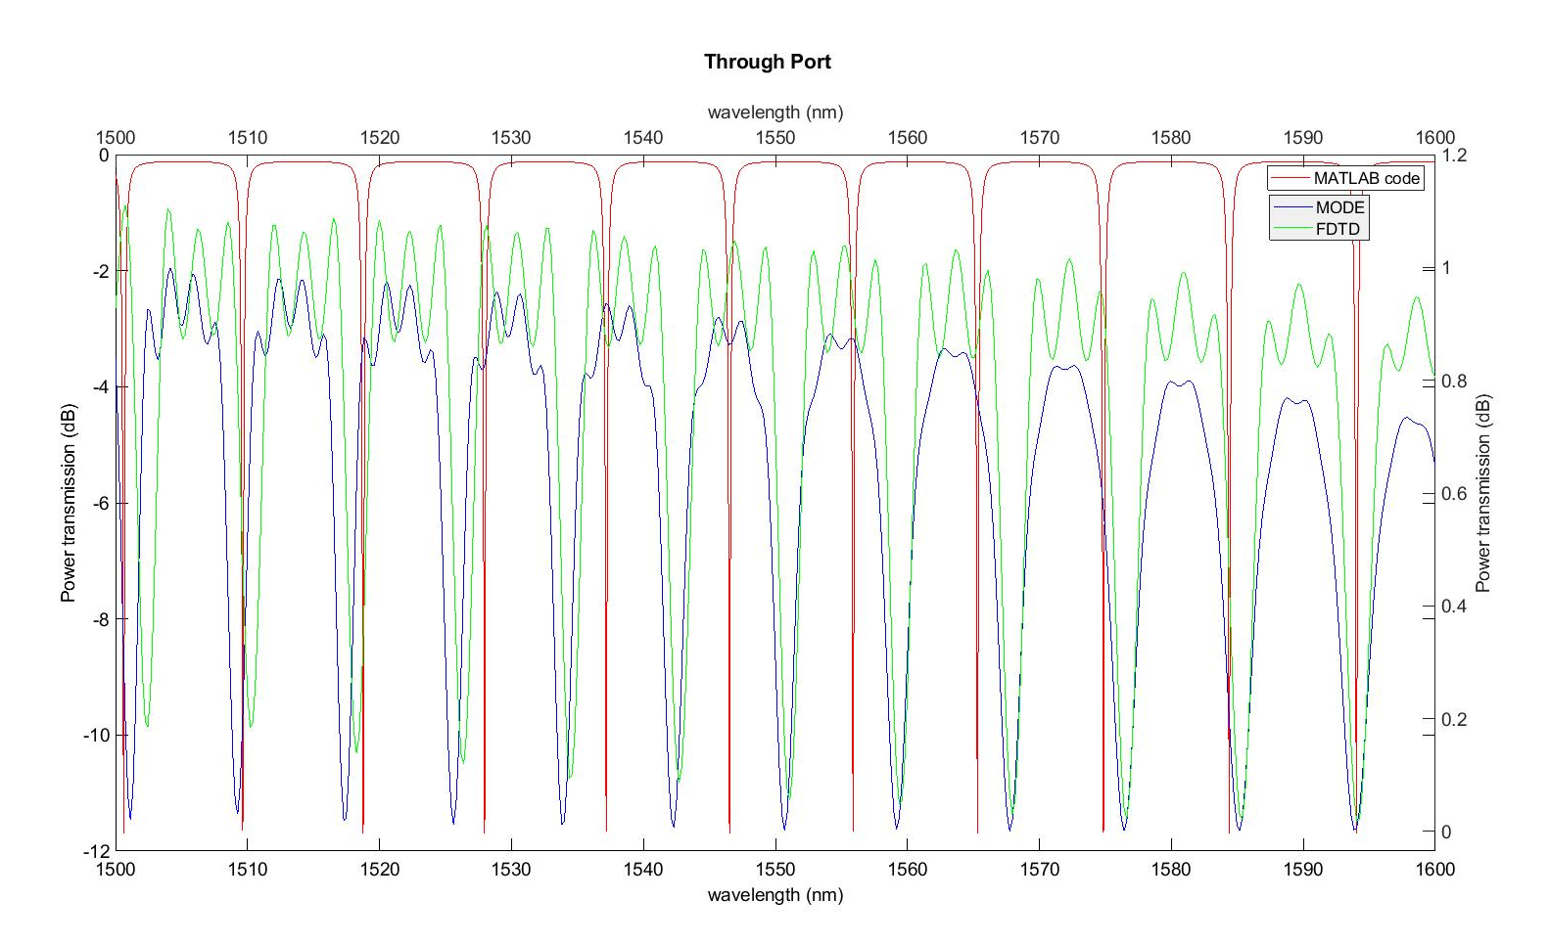

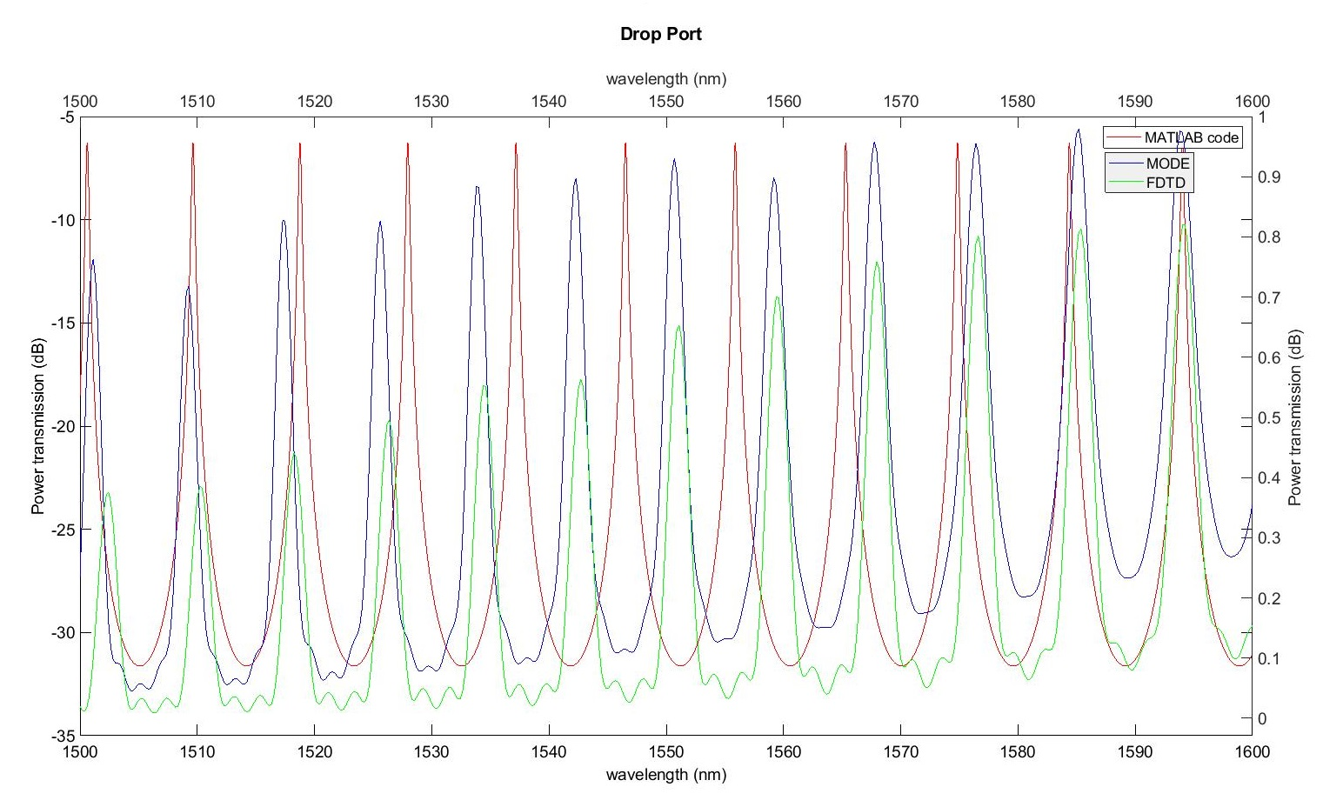

The left y-axis displays the values of simulations from MODE and FDTD and the right y-axis displays the values from MATLAB code.

**Results:**

After normalizing the data from MATLAB code, the following plots were obtained and the results f all the simulations were very similar.

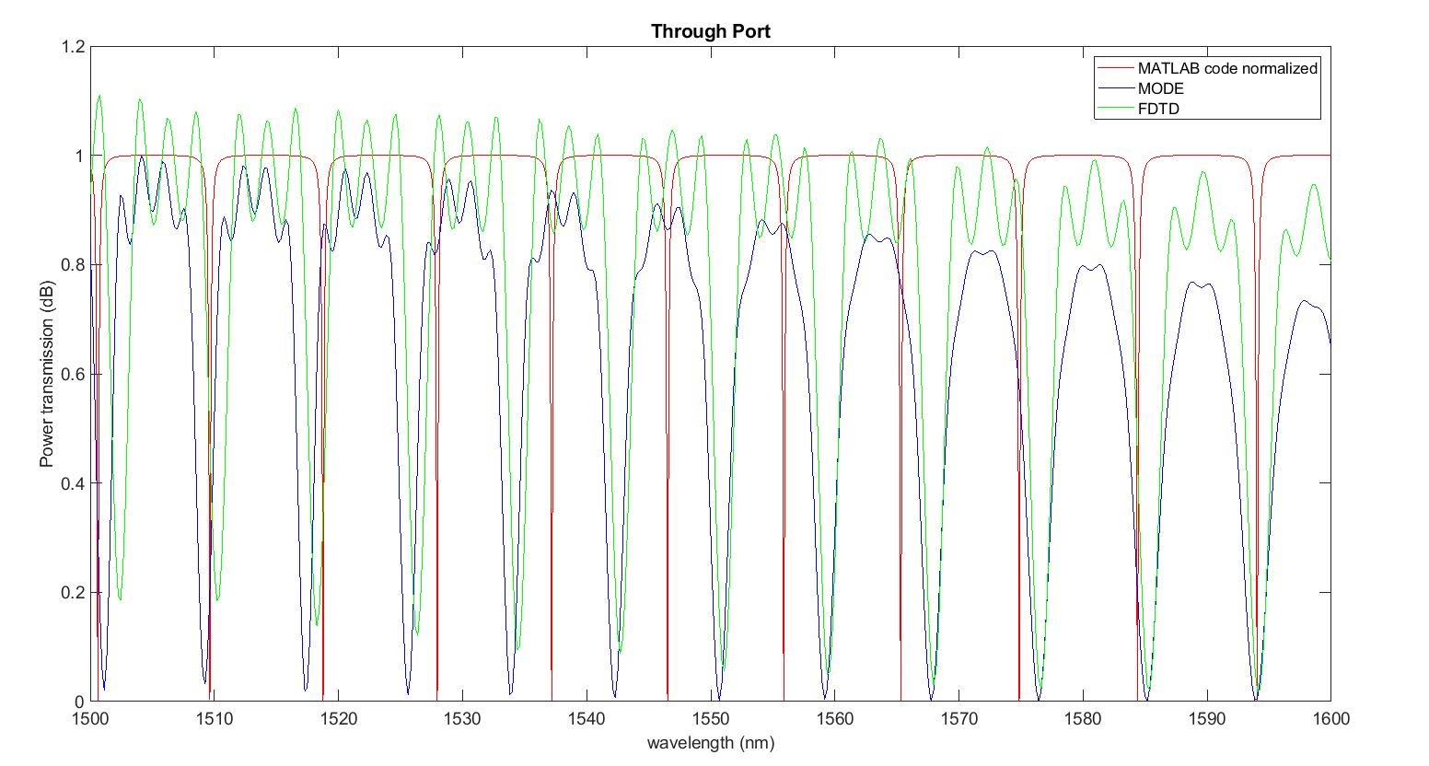

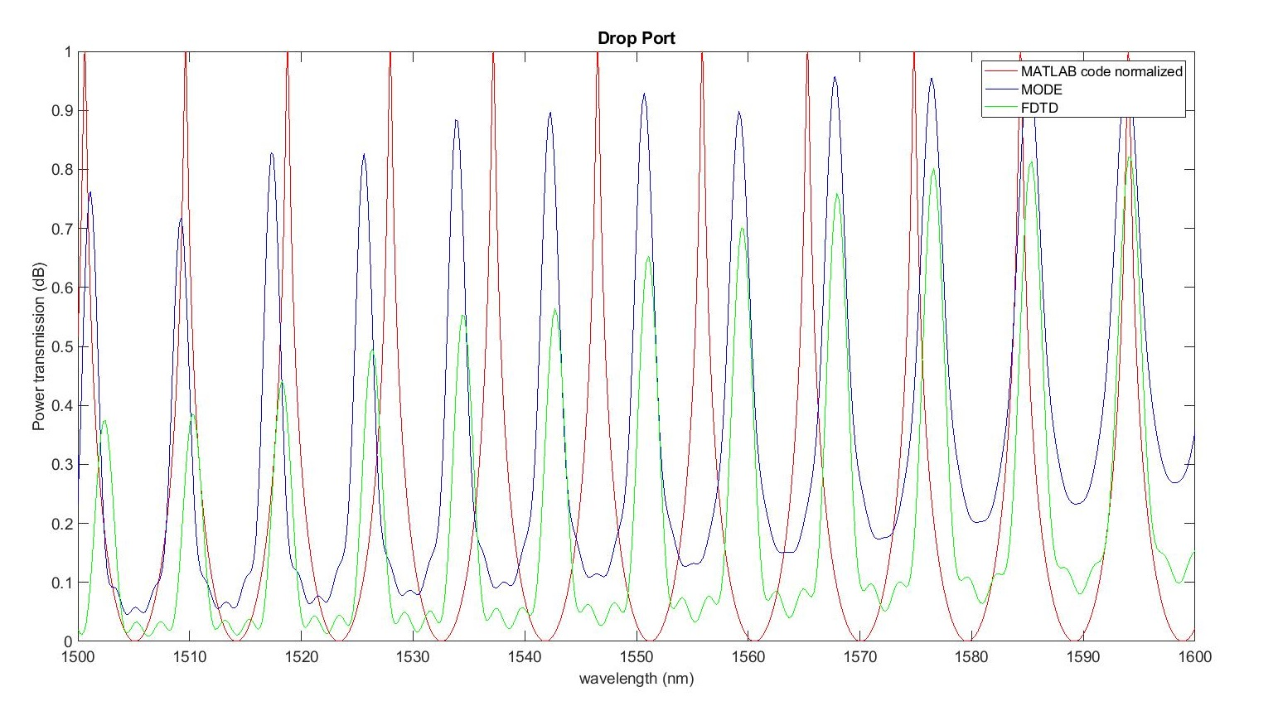

When the TMM_ring.m is simulated, 4 plots are obtained. Figure 3 and 4 are the normalized plots.

**Conclusion:**

As we can see, since the MATLAB code is based on just the mathematical equations of photonics its plot is quite symmetric and holds the trend as compared to the plot obtained from MODE and FDTD simulations. Although the MODE (low accuracy) and FDTD (high accuracy) take all parameters and properties of photonic design into consideration. From the plots of MODE and FDTD, ringing was observed. I noticed as I was designing the ring resonator that as I increase the radius of the MRR this ringing became more significant. Hence, as per my intuition, as the radius of the ring increases, the losses such as insertion and bending losses increase because more area is overlapped by the ring.